**Project Initialization and Planning Phase**

| Date | 4 July 2024 |
| --- | --- |
| Team ID | SWTID1720092248 |
| Project Name | Revolutionizing Liver Care: Predicting Liver Cirrhosis Using Advanced Machine Learning Techniques |
| Maximum Marks | 3 Marks |

**Customer Problem Statement Template:**

Early detection of liver cirrhosis is crucial but challenging with current diagnostic methods, leading to delayed treatment and poor patient outcomes. Healthcare providers need a precise, fast, and reliable solution to predict liver cirrhosis using advanced machine learning techniques, improving early diagnosis and patient care.

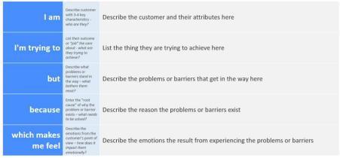

Reference: https://miro.com/templates/customer-problem-statement/

**Example:**



|  |  |  |  |  |  |
| --- | --- | --- | --- | --- | --- |
| **Problem**  **Statement (PS)** | **I am**  **(Customer)** | **I’m trying to** | **But** | **Because** | **Which makes me feel** |
| PS-1 | Researcher studying liver diseases | identify patterns and factors contributing to cirrhosis | The sheer volume of medical data, including patient histories, lab results, imaging studies, and genetic information, can be overwhelming. | Traditional statistical methods may not be able to handle or process large datasets efficiently. | Patients might feel frustrated by the slow and often inconclusive diagnostic process, which creates the feeling of helplessness for the researchers. |
| PS-2 | Health Care Provider | Identify liver cirrhosis in patients | Traditional diagnostic methods may not detect liver cirrhosis until it reaches an advanced stage. | Early signs of cirrhosis can be subtle and not easily detectable through conventional analysis. | Lack of clarity about health status. This uncertainty causes significant anxiety and stress for patients. |